2019 Leaving Cert Physics Paper (Ordinary Level)

2019 Question 1
A student performed an experiment to investigate the laws of equilibrium.
She suspended a metre stick from two Newton spring balances and hung weights from the metre stick until it was balanced and level, as below.
Before setting up the experiment, the student took two measurements.
She measured the weight of the metre stick to be 2 N. She found its centre of gravity at the 50 cm mark.

- How did the student measure the weight of the metre stick?
- How did she find the centre of gravity of the metre stick?
- How did she make sure that the metre stick was balanced and level?
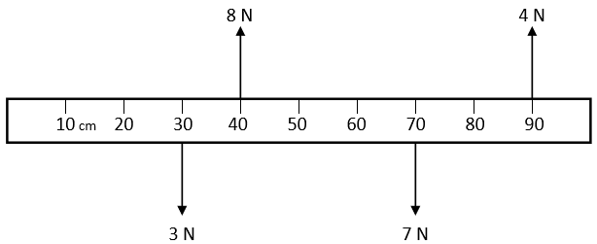
- Redraw the above diagram in your answerbook and include the weight of the metre stick.

The first law of equilibrium states that the sum of the upward forces equals the sum of the downward forces.

- Using appropriate calculations, show that the first law of equilibrium is verified in this experiment.

The second law of equilibrium states that the sum of the clockwise moments equals the sum of the anticlockwise moments.

- Using the 0 cm mark on the metre stick as the fulcrum, the calculations for the clockwise moments are given below.
In your answerbook, complete the calculations to verify the second law of equilibrium.

Clockwise moments | (3×30) + (2×50) + (7×70) | 680 N cm
Anticlockwise moments |  | 680 N cm

2019 Question 2

A student carried out an experiment to measure the specific latent heat of fusion of ice.
During the experiment, ice at 0 °C was added to a calorimeter containing warm water.
- Draw a labelled diagram of the apparatus used in this experiment.
- The ice was crushed before it was added to the water. Why was the ice crushed?

Mass and temperature were measured in this experiment.
- Name (a) one mass measured and (b) one temperature measured.
- Name an instrument used to measure one of the quantities listed in (iii) above.
- State one precaution used in this experiment, other than crushing the ice.

2019 Question 3

A student carried out an experiment to calculate the refractive index, n, of a material.
- Draw a labelled diagram of the apparatus used in this experiment.
- State the formula used in this experiment to calculate the refractive index, n.
- What measurements did the student take during the experiment? What instrument was used to take these measurements?
- Why should the experiment be repeated?
- Other than repeating the experiment, state one precaution that the student took to improve the accuracy of the experiment.

2019 Question 4

A student performed an experiment to measure the resistivity ρ of a piece of nichrome wire of length l, resistance R and diameter d.

R ($Ω$) | 22.8 | 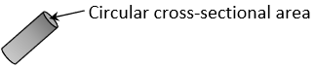
l (m) | 0.98
d (m) | 0.00024 | 0.00028 | 0.00023

- Name the instrument used to measure the length l of the wire.
- Name the instrument used to measure the resistance R of the wire.
- Name the instrument used to measure the diameter d of the wire.
- Use the data to calculate the average diameter of the wire.
- Calculate the cross‐sectional area A of the wire.
- Use the formula $ρ=\frac{RA}{l}$ to calculate the resistivity of the wire.

2019 Question 5

5. (a), (b), (c), etc.
- State the principle of conservation of momentum.
- A force of 2500 N acts on a car of mass 1000 kg. Calculate the acceleration of the car.
- Which of the following is the unit of electrical charge?

ampere coulomb farad volt
- State Boyle’s law.
- A crane moves a load of weight 7000 N to the top of a roof which is 4 m high.
The crane takes 20 seconds to do this work. Calculate the power output of the crane.
- The boiling point of water is 100 °C. Convert this temperature to kelvin (K).
- Explain why it is possible to hear around corners but not to see around corners.
- Name the three primary colours of light.
- What is a semiconductor?
- Name the three forms of nuclear radiation.

2019 Question 6

Neil Armstrong, the first man to walk on the moon, described seeing the Earth as follows:
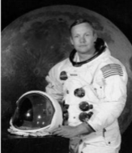
All of a sudden, you could see the whole sphere. A great, gigantic, blue ball, covered with a white lace of clouds. It was spectacular.

Armstrong’s love of flying started at a young age. After joining the navy he became a fighter pilot.
- A jet starts from rest and accelerates along a runway to a top speed of 28 m s^{‐1} in 7 seconds.
What is the acceleration of the jet?
- Acceleration is a vector quantity, while time is a scalar quantity.
Distinguish between a vector quantity and a scalar quantity.
- The moon is constantly in motion, orbiting the Earth.
Explain why an astronaut standing on the moon has a constant speed but a changing velocity.

Armstrong applied to become an astronaut and in 1962 he joined NASA.
- Armstrong had a mass of 90 kg. Calculate his weight on Earth.
Include units in your answer.
- What was Armstrong’s mass on the moon?
- Armstrong’s weight on the moon was only 17% of his weight on Earth. Explain why.

On July 21st 1969, Armstrong became the first man to walk on the moon. An estimated 530 million people watched as he said: That’s one small step for man, one giant leap for mankind. The footprints he made during that walk are still on the moon to this day. The area of Armstrong’s shoe when he took that famous step was 0.03 m². He exerted pressure through his foot onto the surface of the moon.
- Define pressure.
- Calculate the pressure Armstrong exerted on the surface of the moon.

(acceleration due to gravity, g = 9.8 m s^{‐2})

2019 Question 7

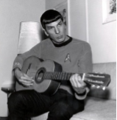
When a musician moves his fingers up and down the strings of a guitar, the frequency of the note changes. When the strings are at their longest, the note heard has a low frequency. The characteristics of a musical note are pitch, loudness and quality.
- Which of these characteristics can be quantified as a frequency?
- Name the property of a wave that affects its loudness.
- When the musician plays the A string on his guitar, the frequency of the note is 110 Hz.
The speed of sound in air is 340 m s^{‐1}. What is the wavelength of the note?
- Describe an experiment to show that sound cannot travel through a vacuum.
The frequency of a sound wave appears to change when it moves past a stationary observer. This phenomenon is called the Doppler effect.
- Describe how to demonstrate the Doppler effect in a laboratory.
- Sound can be described as a longitudinal wave, whereas light is a transverse wave.
Distinguish between a longitudinal wave and a transverse wave.
A labelled diagram may help your answer.
- Waves can undergo reflection, refraction, diffraction, interference and polarisation. While light waves can undergo all five of these wave phenomena, sound waves can only undergo four of them.
Which one of these phenomena do sound waves not undergo?
Explain why.

2019 Question 8

A student measured the temperature of a large bath full of water and a small cup full of water and said “they are both at the same temperature, so they must contain the same amount of energy”.
- Is the student’s statement correct? Explain your answer.
- The thermometric property used by a mercury thermometer is the length of a column of liquid.
What is meant by a thermometric property?
- Name another example of a thermometric property.
- A storage heater consists of an electric heater surrounded by bricks made of a material with a high specific heat capacity.
Define specific heat capacity.
- Why does the material in the bricks need to have a high specific heat capacity?
- A kettle supplies heat to 1.5 kg of water and raises its temperature from 15 °C to 88 °C.
Calculate the heat energy gained by the water in the kettle.
- If heat energy continues to be supplied, the water will reach its boiling point and change state.
Apart from boiling, name one other change of state that can happen to water.
- What is meant by latent heat?
(specific heat capacity of water = 4200 J kg^{‐1} K^{‐1})

2019 Question 9
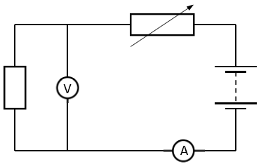
(a) The circuit on the right is used to demonstrate Ohm’s law.
- What is meter A?
- What is meter V?
- Which of the graphs below shows Ohm’s law being obeyed?
Explain your answer.

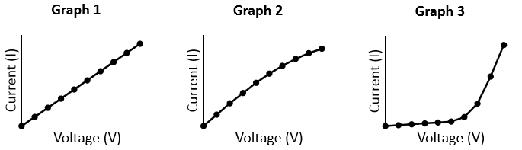

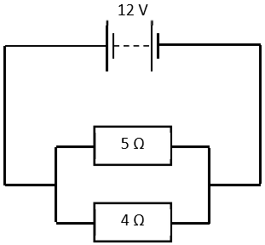

(b) In the circuit on the right, the resistors are wired in parallel.
- Calculate the total resistance in the circuit.
- Calculate the current flowing through the circuit.

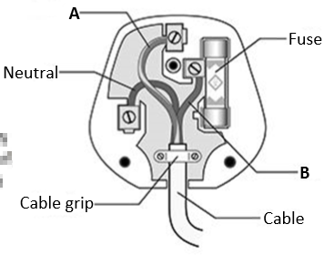
(c) The diagram on the right shows the parts of an electrical plug.

- Name the wire labelled A.
- Name the wire labelled B.
- State the function of the fuse.
- There are two other devices used in the distribution box of a domestic circuit that carry out a similar function to the fuse.
Name one of these devices.

2019 Question 10

The last will and testament of Swedish scientist Alfred Nobel established the five Nobel Prizes in 1895. The prizes in physics, chemistry, peace, medicine, and literature were first awarded in 1901. The electron was discovered in 1897 by a British scientist, J.J. Thomson, while he was using a cathode ray tube. In 1906 Thomson won the Nobel Prize in physics for his discovery.
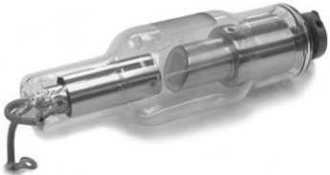
- State two properties of an electron.
- How are the electrons produced in a cathode ray tube?
- How could the beam of electrons be deflected?
- What happens when the beam of electrons strikes the screen?
- State one use of a cathode ray tube.

In Germany, around the same time, another scientist, Wilhelm Röntgen, was also working with cathode ray tubes.
During the course of his work, and completely by accident, Röntgen discovered X‐rays. He won the Nobel Prize in physics in 1901.
- What are X‐rays?
The photograph shows an X‐ray tube. When the electrons strike the target, a large amount of their kinetic energy is converted into heat energy.
- State one way in which an X‐ray tube is designed to take account of this large amount of heat energy.
- Why might an X‐ray tube be surrounded by lead shielding?
- State one use of X‐rays.
- State one hazard associated with X‐rays.

2019 Question 11
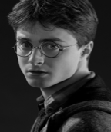
Read the following passage and answer the questions below. One of the most common sights anywhere in the world are eyeglasses. Since we depend so much on the lenses inside those frames to improve our view of the world, you might wonder just what goes into creating them. On the back of your eye is a complex layer of cells known as the retina. When you look at an object, an image is formed on the retina.
The retina reacts to light and conveys that information to the brain. To do all that, the eye has a lens between the retina and the pupil and a transparent covering called the cornea.

The pupil allows light to enter the eye. The lens, the ciliary muscles and the cornea work together to focus the image onto the retina. The lens has a different power depending on whether the object being viewed is nearby or far away. Sometimes the eye doesn't focus quite right. Most vision problems occur when the eye cannot focus the image onto the retina. The most common problems associated with the eye are as follows:
Myopia (short sightedness) occurs when a distant object looks blurred. Short sightedness is corrected with a diverging lens. Hyperopia (long sightedness) occurs when a nearby object looks blurred. Long sightedness is corrected with a converging lens. Placing the correct type and power of lens in front of the eye compensates for the eye's inability to focus the image on the retina.
Adapted from https://science.howstuffworks.com/innovation/everyday‐innovations/lens6

- Name the part of the eye where an image is formed.
- What is the function of the pupil?
- The eye can focus light from both nearby and distant objects. Describe how the eye changes to allow this to happen.
- Name the two most common eye defects. What type of lens corrects short sightedness?
- Draw a sketch of this lens.
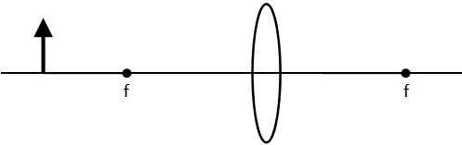
- Copy the diagram below into your answerbook and complete the ray diagram to form a real image.

- The power required to clearly view a nearby object is 38 m^{‐1}.
A person with an eye defect has a maximum power of 32 m^{‐1}.
Calculate the power of the lens required to correct this defect?
What is the focal length of this lens?
- Light undergoes refraction as it passes through a lens. What is meant by refraction?

2019 Question 12 (a)

A cannonball of mass 7 kg is shot from a cannon straight up into the air, with an initial velocity of 50 m s^{‐1}.
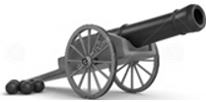
- State the principle of conservation of energy.
- Calculate the cannonball’s kinetic energy as it is fired.
- As the cannonball rises, its kinetic energy is converted into another form of energy. Name this energy.

- Calculate the greatest height reached by the cannonball.
- The cannonball has a volume of 0.0009 m³.
Calculate the density of the cannonball.

(acceleration due to gravity, g = 9.8 m s^{‐2})

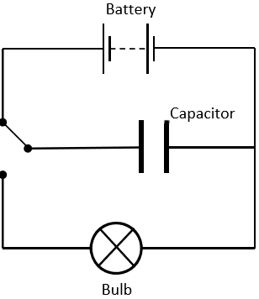
2019 Question 12 (b)
A capacitor is used in the flash of a camera.
- Define capacitance.
- State the unit of capacitance.
- The light energy emitted by a flash is supplied by a capacitor. The charge on the capacitor is 0.025 C and the potential difference across it is 250 V.
Calculate the capacitance.

- In the flash circuit of a camera, energy is stored up and then suddenly released.
A capacitor stores energy when it is charged.
The circuit shown can be used to demonstrate that a capacitor stores energy.
Explain how the circuit is used.
- State another use for a capacitor.

2019 Question 12 (c)

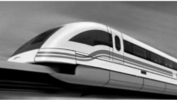
Magnetically levitated trains (known as maglev trains) use magnets under their carriages to float above the magnetic tracks.
Like poles repel, and this is the property of magnets that is used in maglev trains.

- State one other property of magnets.
- What is meant by a magnetic field?
- Describe an experiment to plot the magnetic field of a bar magnet.
- State one other use of magnets.

2019 Question 12 (d)

Both nuclear fission and nuclear fusion are processes by which the nuclei of atoms are altered to create energy.
- ${}_{92}^{238}U$is a uranium atom. How many protons are in this uranium atom?
- How many neutrons are in this uranium atom?
- ${}_{92}^{235}U$ is another isotope of uranium. What are isotopes?
- Distinguish between nuclear fission and nuclear fusion.
- State one advantage and one disadvantage of nuclear energy.

